**DAILY ONLINE ACTIVITIES SUMMARY**

|  |  |  |  |  |  |  |  |
| --- | --- | --- | --- | --- | --- | --- | --- |
| **Date:** | 30-05-2020 | | | | **Name:** | Gudugunti Anirudh | |
| **Sem & Sec** | IV - A | | | | **USN:** | 4AL18CS023 | |
| **Online Test Summary** | | | | | | | |
| **Subject** | | | Data communication & Complex analysis, probability and statistical methods | | --- | | | | | | |
| **Max. Marks** | | 30,30 | | **Score** | | 27,30 | |
| **Certification Course Summary** | | | | | | | |
| **Course** | Python in ML | | | | | | |
| **Certificate Provider** | | | Great learning academy | **Duration** | | | **2 hrs** |
| **Coding Challenges** | | | | | | | |
| **Problem Statement:**Write a C Program to count Uppercase, Lowercase, special character and numeric values for a given String | | | | | | | |
| **Status:** completed | | | | | | | |
| **Uploaded the report in Github** | | | | yes | | | |
| **If yes Repository name** | | | | https://github.com/alvas-education-foundation/anirudh_gudugunti/tree/master/daily_progress | | | |
| **Uploaded the report in slack** | | | | yes | | | |

Online Test Details:

**Data communication:** The online test was from module 3 and 4 which was about bandwidth utilization, switching, error detection and correction, data link control, media access control. Introduction to data link layer and IPv4 & addressing sub netting. There were 30 questions and the duration was 45 minutes. The questions were optimal and were easy. The score that I got in the test is 27/30.

**Complex analysis, probability and statistical methods:** The online test was from module 3 which was about probability distribution. There were 20 questions where 10 was for 1 mark each and the remaining 10 for 2 marks each and the duration was 45 minutes. The questions were optimal and were easy. The score that I got in the test is 30/30.

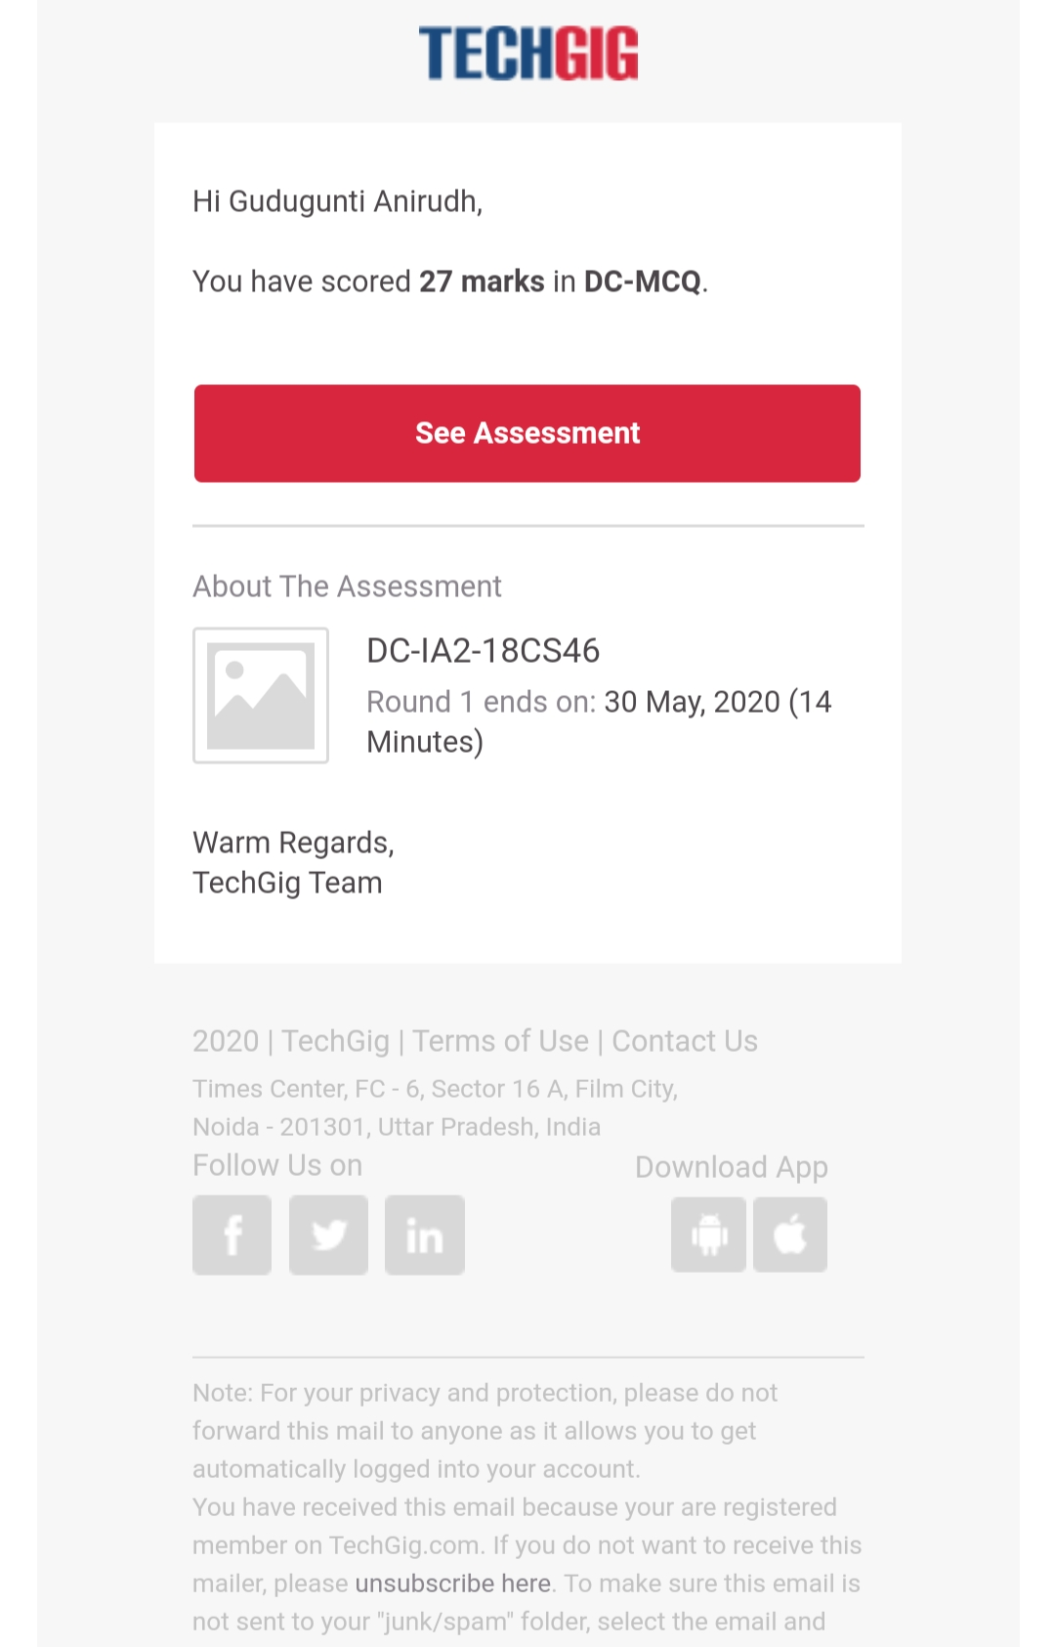

Certification Course Details:

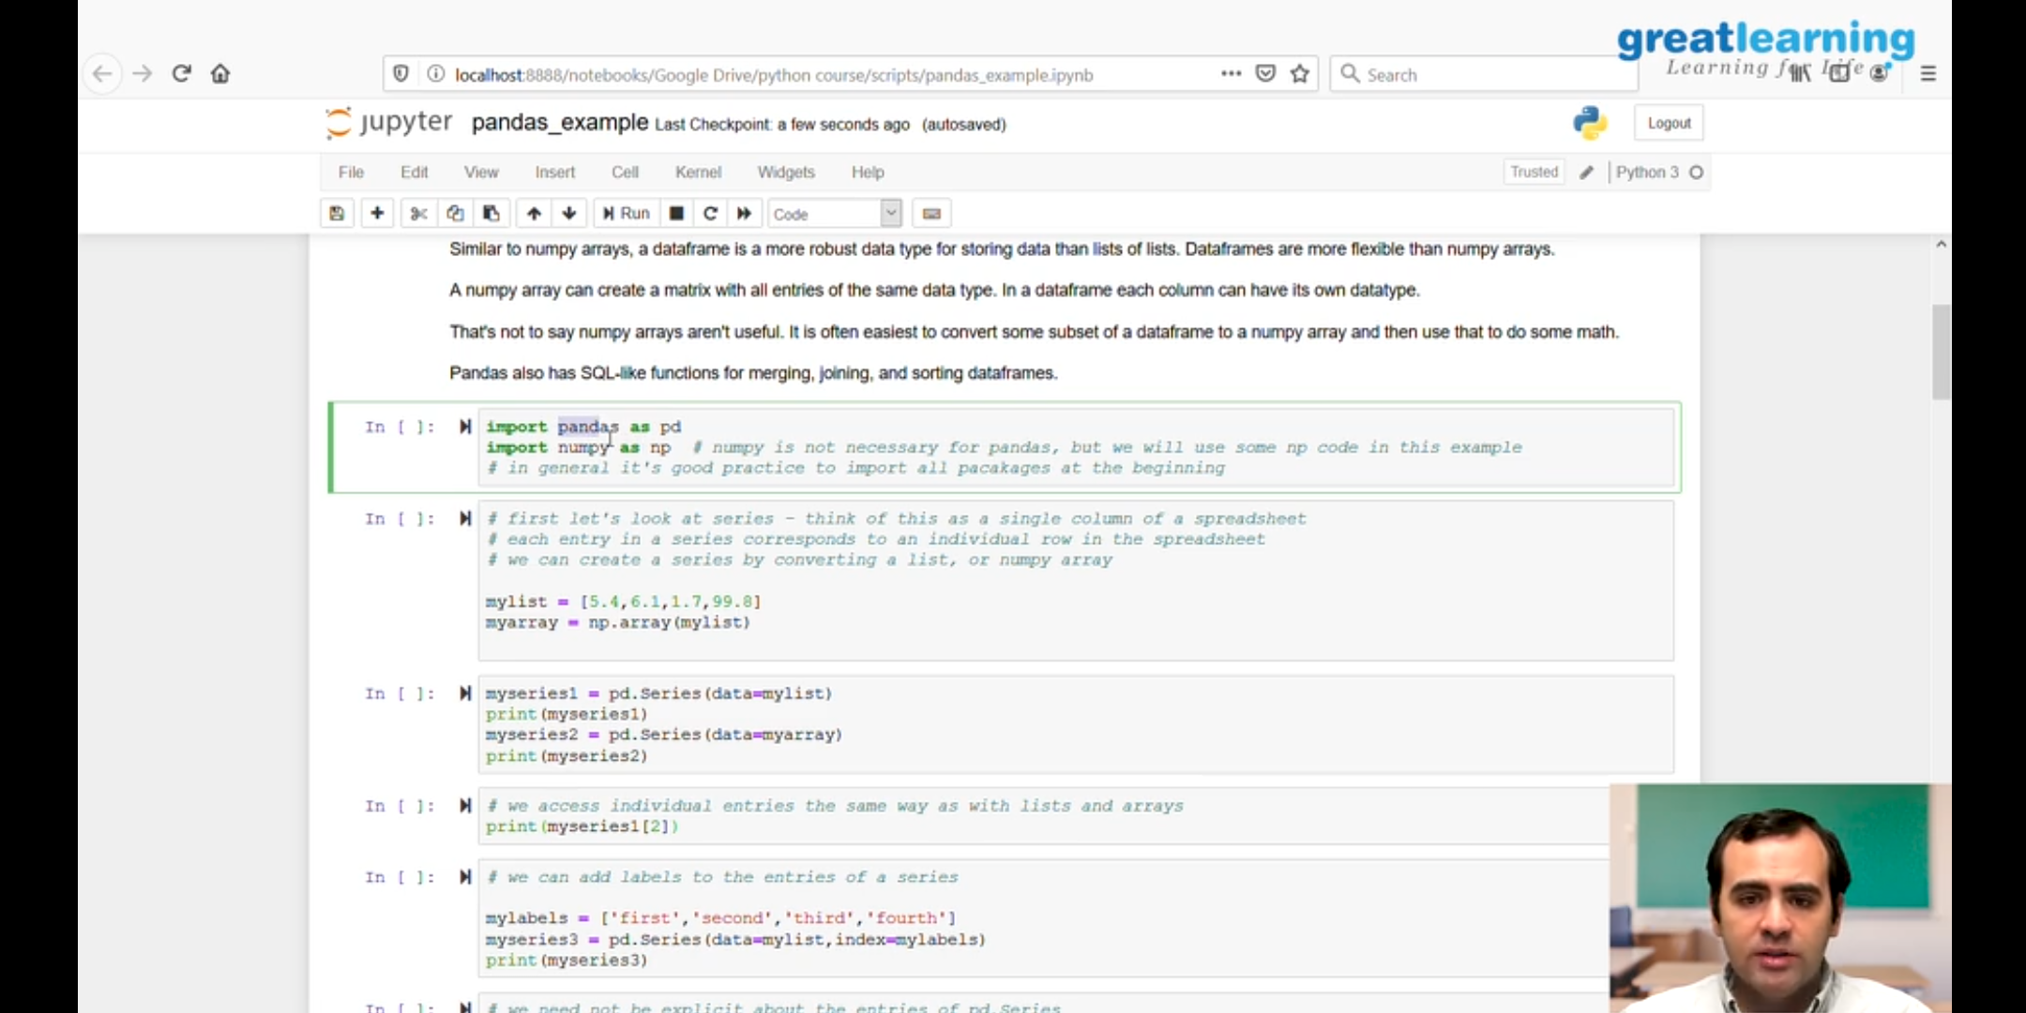

1. Detailed instructions on NumPy, series,data frames,pandas.

2.A NumPy can create a matrix with all entries of same data type.

3. Pandas also has SQL like functions for merging,joining, sorting data frames.

Coding Challenges Details:

Problem 1: (using C language) Write a C Program to count Uppercase, Lowercase, special character and numeric values for a given String.

